DARREN PATTERSON
CHRISTIAN ACADEMY
FAMILY HANDBOOK
REVISED March 2022

LOCATION  518 S San Juan Ave, PO 1243  Buena Vista, Colorado 81211 | HOURS  Tuesday – Friday 7:45 - 3:30 | CONTACT  Phone: 719.395.6046  Fax: 719.395.2055
www.dpcaweb.org
HEAD OF SCHOOL  Joshua Drexler  admin@dpcaweb.org | OFFICE MANAGER  Lynn Graff  l.graff@dpcaweb.org | FINANCES  Maggie Stark  m.stark@dpcaweb.org

TABLE OF CONTENTS

Get to Know DPCA 4
  - Mission, Staff Values, Our Story
  - Staff Values

Who is Darren Patterson? 4

Purpose of Handbook 5

What Makes DPCA Different 5

Family Involvement 7

Volunteers 7

Student Expectations 8
  - Code of Conduct … 8
  - Electronic Devices … 9
  - Student Internet Use Policy … 9
  - Dress Code … 10

Communication 10
  - Stay in the Know … 10
  - Conflict Resolution … 11

General 11
  - School Hours and Schedule … 11
  - Attendance and Absences … 12
  - Snow Days … 12
  - Grades and Eligibility … 12
  - Homework Help … 13
  - Honor Roll and Awards … 13
  - Library Books … 13
  - Recess Rules … 13
  - Playground Rules … 14
  - Lost & Found … 14

Health Services 15

School Safety 18
  - Restricted Access … 18
  - Pick-Up Authorization … 18
  - School Visitors … 18
  - Background Checks … 18
  - Student Photo Permissions … 19
  - Student Records … 19
  - Sensitive School Spaces … 19
  - Safety Drills … 19
  - In the Event of an Emergency … 20
  - Investigations … 20

Tuition, Fees, and Purchases 21
  - Fee Schedule … 21
  - Payment … 21
  - Withdrawal from School … 22
  - Refund Policy … 22
  - Lunch Fees … 22
  - Online Payment … 22

GET TO KNOW DPCA
Darren Patterson Christian Academy (DPCA) is a PreK-8th, Christ-centered Expeditionary Learning school that has been serving students in Chaffee County since 1982.

OUR MISSION
Darren Patterson Christian Academy guides students in knowledge, character, and faith to discover an authentic love of learning and a life of opportunity.

STAFF VALUES
In order for the school's mission to be translated from words into reality, we are committed as a team to modeling the following behaviors in ways that consistently cultivate a joyful, welcoming, Christ-centered culture:

LEADERS IN LEARNING | As educators, our staff model a love of learning for their students not only by continuing to pursue professional development opportunities, but by remaining willing to grow and change in order to best serve their students.

MOTIVATED BY LOVE | All the ways our staff serve parents, their children, each other, and our local community are authentically characterized by love, so that our actions may be an indicator of Christ's work in our hearts.

BUILDERS OF COMMUNITY | Our staff is focused on developing personal relationships with students, a positive school culture, and a supportive work environment in order to unify our learning community and best serve the broader community of Chaffee County.

WHO IS DARREN PATTERSON?

The name “Darren Patterson Christian Academy” is an important part of our school's culture as it represents our deeply rooted belief that young people can change the world. So, who is Darren Patterson? He was a 14-year-old boy who was killed by a drunk driver in a car accident on Thanksgiving Day in 1981... but the story didn’t end there. This one little boy continues to impact the lives of hundreds of kids in our community, past and present.

​Darren grew up in Buena Vista and expressed a strong desire to attend a Christian school, but there were none in the area at the time. After his death, the people who loved him most decided to honor his strong desire by starting a Christian school. Family and friends banded together to create an endowment fund, but when DPCA opened its doors one year later and invited the 1,500 residents in Buena Vista to consider a Christ-centered education for their students, most people said that the school would never be able to make it. There simply were not enough students in the community to fill up multiple schools. There were 15 students that first year.

By 1996, the school had outgrown the church facility that it was renting and so began construction on a beautiful, new facility to house the growing student body. In 2007, this facility was tripled in size and expanded to include an additional wing of classrooms, gymnasium, and cafetorium space.

Here DPCA stands 38+ years later, with a healthy number of students and tremendous support from the local community that enables our school to thrive. Without Darren's desire, families living in Buena Vista and the surrounding area would not have had the option of choosing a joyful, rigorous, Christ-centered education. One little boy's dream paved the way for hundreds of kids to experience more than just a school, but a place where they are known, loved, and believed in. We see students as powerful agents of change, capable of using the knowledge, skills, and character that they develop here to go out and change their communities and our world.

PURPOSE OF HANDBOOK
Because of the primary role of the family in a child's education, DPCA believes that partnership is paramount. The school’s role is to aid the parent in the overall education of the children that God has given them.
Therefore, the design and content of this Parent/Student Handbook has a fourfold purpose:
- To invite and encourage parents to play an active role in their child’s education by understanding why DPCA operates the way it does, by getting involved in every way possible, and by cooperating with DPCA to provide the best Christian education available.
- To inspire parents to see and understand potential developments in their child’s life because of a God-centered education.
- To instruct parents on how our philosophy, purpose, values, programs, and policies all work together. We attempt to do nothing haphazardly; we aim at unity, consistency and integrity in all that we do.
- To inform parents on what they need to know regarding the details of their student's education.
Darren Patterson Christian Academy reserves the right to interpret the content of this handbook, including the rules and regulations governing the academic and non-academic conduct of students. This handbook is not a contract, nor is it intended to be so construed. Darren Patterson Christian Academy reserves the right to modify and/or amend the content of this handbook at any time during the year. If any written modification or amendment is made to this handbook, a copy of such modification or amendment will be distributed to students and parents.

WHAT MAKES DPCA DIFFERENT?

We are distinctly Christ-centered. While not affiliated with any church or denomination, the culture, curriculum, and staff of DPCA are centered on a Biblical worldview. Staff affirm the Statement of Faith found at the end of the handbook and on our website. Our school is a member of the Association of Christian Schools International (ACSI). However, you don’t have to be a Believer to join our learning community. We welcome students of all beliefs and backgrounds to experience the joy of learning at DPCA.

We are an Expeditionary Learning school, which means our teachers are trained in the most engaging teaching practices for today’s students and that we embark on academic and outdoor expeditions together throughout the year. Our academic expeditions take place once a year. They are 6 - 8 week in-depth studies that are interdisciplinary and incorporate community experts, off-site fieldwork, and culminate a final product that demonstrates their learning while benefitting others in the community. Our outdoor expeditions take place four times a year and center around adventure activities as a way to emphasize character formation, spiritual development, leadership qualities, and teach technical outdoor skills. More information about Expeditionary Learning is available at the end of the handbook.

We go to school four days a week in order to preserve the primacy of family as the main influence on a student’s life, to create time and space for students to play more and pursue individual interests outside of a classroom setting, and to allow students to be more rested and focused while at school.
We limit enrollment to 100 students K-8th in order to preserve small class sizes and the family culture of our school. As an intentionally small school, we aim to make a big difference in the lives of students through personalized care and instruction.

We teach to each child rather than to their grade. With the majority of our grades being combined classrooms, we emphasize two-year relationships with students. Multi-age grouping allows a classroom to accommodate different levels of maturity and capabilities. It also allows the older grade to experience leadership opportunities at an earlier age and cultivates a greater sense of continuity and community among the whole school.

We care about who students are becoming, not just what they know. Alongside rigorous academics, we emphasis character and spiritual development in order to form and inform people with the knowledge, character, and skills to become agents of good in their communities. To this end, our staff and school culture carry a Biblical perspective while welcoming students of all faiths.
Community is central to our curriculum. Often, students venture out into the community to learn from experts, or we invite knowledgeable community members into the classroom in order to connect learning to real life. Fieldwork, community collaboration, and flexible classroom spaces are a norm here, as is presenting to the public. When students have an authentic audience the quality of their work grows.

Adventure deepens our learning. Students backpack, rock climb, hike, xc ski, snow shoe, dog sled, and more, with a focus on leadership and character development, spiritual formation, and teaching technical outdoor skills. Although outdoor expeditions do not have academic objectives, teachers say they see students return to class with mindsets such as increased confidence, ability to persevere through challenge, and greater awareness that enables them to learn better.

We are a staff-student-parent team. We encourage every member of our team to participate in the learning process by being actively engaged, openly sharing feedback and perspectives, and taking responsibility for their part in the learning process as we all grow, learn, support, and celebrate each other. School leaders, teachers, students, and families work together to model academic courage and create a culture of respect, responsibility, and joy in learning.

FAMILY INVOLVEMENT

We invite, and strongly encourage, parents and students to be active crew members with us, rather than passengers. We want to hear parents’ perceptions about their children and their experiences at DPCA. We expect parents to check in with their children’s teachers and to be interested in their learning. We want parent feedback about our expeditions and our culture. We expect our students to be responsible for their own learning. Our teachers do not pour knowledge into passive students. Within this context, we expect students to explore, wonder, hypothesize, create, and discuss their ideas about the world. This is hard work. We expect every member of the team to actively participate in the learning experience. One of the shared values of DPCA is a high level of parental involvement to ensure our success and growth.

VOLUNTEERS

At Darren Patterson Christian Academy, we welcome volunteers as a source of special skills and the much-needed extra hands in the classroom. Volunteers are very much appreciated for the support they extend to teachers. All volunteers, including parents, must follow board policy regarding non-supervised contact with students and are required to undergo a background check if they work directly with students on a regular basis or chaperone any extended school sponsored event that is overnight. Please check with the office if you have any questions.
Our expectation is that parents commit to volunteer for the school each semester. Here are a few examples of how you can volunteer:

• School set-up and care
• Teacher support
• Project preparation
• Fieldwork transportation
• Classroom involvement
• School-wide activities and committees
- Building and grounds upkeep
- Fundraising involvement
- Office / clerical work

Parents are welcome to join us for Friday Chapels anytime! Chapel is 8-8:30am every Friday.

STUDENT EXPECTATIONS

CODE OF CONDUCT

Darren Patterson Christian Academy is committed to creating a positive and safe environment for all students so that they can effectively learn and grow. While we discuss Christian character traits and strive to create a family culture where each student feels known and loved, our school is not immune to behavioral issues or conflict. When these things do arise, we address them using Christian principles to guide conversation and consequences. Please inquire with the Head of School for a more detailed look into our discipline policies.

- Students are expected to maintain an inclusive social environment throughout the day.
- Students are expected to be respectful of one another’s property and school property. Any lost property should be turned in to the main office. Theft and vandalism (graffiti, defacing of school property) are serious offenses.
- Students are expected to leave the classroom clean and pick up after themselves and/or others. All students are expected to participate in an end-of-day clean-up as requested or assigned.
- Students are expected, in all cases, to pick up after themselves and to help keep the building neat. Trash should be properly disposed of, projects cleaned up when completed, supplies returned to their proper place, etc.
- Running or excessive noise in the hallways, classrooms, cafetorium, or offices is not permitted.
- Students must have permission before entering the staff hallway or any staff office.
- Teacher desks and computers are off-limits to students unless the teacher to whom they belong has given specific, individual permission.
- Students must have specific permission to be in special-use areas of the building such as the music room, library, gymnasium, conference room, science lab, stages (including upper levels of the stage and stage areas), mechanical rooms, storage areas, media control room, etc.
- Eating is permitted only in the concrete areas of the cafetorium, unless permission is received from a teacher or other staff member to eat elsewhere. Drinks are permitted in classrooms according to teacher’s guidelines; students must use containers with lids.
- Students may not possess lighters, fireworks, knives, weapons of any kind, or any other item or substance designed or intended to cause harm to themselves or others on the school grounds or in the school building. Violations of this policy may result in immediate suspension from classes and may be referred to local law enforcement authorities as well.
- Rude or foul language is not acceptable.
- Physical fighting, real or play, is not allowed.
- Games or activities that involve tackling, wrestling, or throwing objects (other than throwing toys such as balls or Frisbees) are not permitted on the playground.
- Bullying is a serious issue and will not be tolerated. Bullying behavior involves an imbalance of power, is repeated over time, and is intentional. It can include, but is not limited to, the following: physical or verbal abuse, stealing or disrespect of property, malicious or hurtful name calling, verbal threats, unwanted and disrespectful attention, or any behavior that has the intention or effect of harming or intimidating others.
- In addition to the aforementioned guidelines for all students, teachers may establish specific rules and procedures for their classrooms that students are expected to follow. Teachers may use a variety of means to correct inappropriate behavior in the classroom, including verbal warnings or reprimand, loss of privileges, loss of reward, time-outs, additional classroom work, additional special projects, conversations with Head of School, detentions after school, etc.
While some infractions have consequences associated with them as defined in school policies, it should be noted that the goal of discipline is to teach our students, not to punish. We recognize that students are prone to make errors in judgment from time to time. We want to work with students and families to make these events meaningful learning opportunities that teach the student what not to do in the future and why that is important. This partnership between the school and the family is paramount in teaching our students and helping them reach success.

ELECTRONIC DEVICES

- Middle Schoolers are allowed to keep their phones in their lockers for use before and after school. Phones are not allowed during the school day.
- Elementary students are not allowed to have phones or devices in class or at school on a routine basis. If phones are necessary, parents need to discuss with the teacher(s).
- Devices may be used in class only for education purposes and as directed by the teacher. If devices are used for any other reason that has not been approved by the teacher, it will be taken away until the end of the day. If the problem persists then parents will be contacted to develop an alternative plan.
- Students are not allowed to respond to text messages in class. The best way to communicate with your child is to call the front office and we will get a message to your student and/or the teacher.
- Students have access to the phone in the front office, by permission only, in order to contact parents/guardians in cases of forgotten homework, illness, or emergency, etc.

STUDENT INTERNET USE POLICY

Middle School students are granted access to Google Chromebooks for school usage, which they use for specific academic purposes during class time under teacher supervision. Students are expected to abide by generally accepted rules of internet etiquette and to be ethical digital citizens. While teachers do their best to enforce operative guidelines and internet safety, DPCA disclaims all liability for the content of material that a student may access on the internet, any damages suffered in the course of, or as a result of, a student’s internet use, and for any other consequences of a student’s internet use.

DRESS CODE

- Be neat, clean, and modest.
- Dress appropriately for the activities scheduled that day.
- Shorts and sleeveless shirts must be modest. No spaghetti straps.
- Middle School girls, when wearing leggings, must wear shirts that are mid-thigh in length.
- Dress will not be worn that causes, or is likely to cause, disruption of the educational process including, but not limited to, hats or sunglasses that obscure a student’s face while in class, or clothing that may be deemed to be provocative or offensive or which promotes illegal activity.
- Footwear is to be worn to school at all times.
- Clothing must be worn in an appropriate manner. Pajama bottoms or slippers are not permitted except on special spirit days or as designated by teacher.
- Parents/guardians should remember that physical education classes and recess usually take place outdoors. In cold weather, students must come to school with adequate warm clothing to allow them to be outside for up to 45 minutes at a time.
- Disciplinary action for violation of any dress standards will include notification of the violation, the requirement that the clothing be changed before re-entering class and, at the discretion of the Head of School, a parent conference.

COMMUNICATION

Communication is of great importance to us and we will always do our best to communicate upcoming events, volunteer needs, and class information clearly and consistently. There are several ways we share information with our families about what’s happening in classrooms and in our school community.

It is very important that the school office have your current contact information for all students. If any contact information changes during the school year, it is the parent’s responsibility to notify the school office of the changes.

STAY IN THE KNOW

  - Regular Emails. Announcements and reminders are sent from the Office Manager: l.graff@dpcaweb.org.
  - Remind Texts. Parents and guardians are invited (through a link that will be emailed to you) to signed up for these texts in order to communicate the occasional SNOW DAY and any other urgent matters. We will also use this to communicate any Lockdowns and/or Lockouts that may be in effect.
  - Thursday Folders. Students bring home weekly class newsletters, flyers for events, etc.
  - Quarterly Newsletter. Sign-up through our website (www.dpcaweb.org) to be on the email list to receive this automatically. You’ll also find a copy of the newsletter on our website.
  - Social Media. Follow us on Facebook and Instagram to see more of what learning looks like day-to-day, read helpful articles, and connect with other parents.
  - New Family Orientation. The week before school starts, we host an information night for families who are new to the school in order to help prepare students and educate parents.
  - Report Cards. At the end of each quarter students will come home with a grade report. After reviewing the report card, parents are to sign and return it to the school. At the end of the school year, students can take their final report cards home to keep.
  - Parent-Teacher Conferences. At the end of each semester parents are invited to meet with their student’s teacher(s) to discuss their child’s progress. In addition, parents are encouraged to schedule conferences with the teacher, as desired, and teachers are encouraged to ask parents for a conference if the need arises.
  - Head of School. When important matters arise, the Head of School will reach out to parents and guardians through phone calls and/or emails. The Head of School will also rely on the Office Manager to send out message on his/her behalf.

CONFLICT RESOLUTION

- Parents are encouraged to please communicate any concerns, issues, or questions you have regarding your child’s teacher, your child, another student, or another parent, with your child's teacher first. If necessary, the administrator or other parents will be asked to engage in the conversation.
- Parents, for the safety of all of our students, refrain from approaching any children who are not your own directly with concerns or issues on school grounds. Please follow the above protocol.

Any community member has the right to submit a suggestion or complaint in reference to any staff
member, policy, regulation, program, or procedure. In order to move in an orderly but expeditious manner, communication should begin at the lowest level (the person directly involved) and move to subsequent levels of supervision when resolution does not occur. If the matter cannot be resolved informally with the individual in question or the issue is too sensitive, then the subject of the matter should be put in an email or written letter and submitted to the individual’s supervisor.

GENERAL

SCHOOL HOURS & SCHEDULE

Class is in session Tuesday – Friday from 7:45am - 3:30pm for 1st - 8th grade students. Kindergarten morning class dismisses at 12:00pm.

School doors open at 7:30am and close at 3:45pm, with teachers remaining with any students who have not yet been picked up.

Visit our website to download a copy of the school calendar. Please call the office, or contact the student’s teacher, to obtain a copy of class schedules.
ATTENDANCE & ABSENCES

There is a direct relationship between academic success and school attendance. In order to maximize the benefits that a student can obtain from school, it is essential to attend regularly.

- Parents, if an unexpected absence occurs, call the front desk (719.395.6046) to inform the school as soon as possible of your child’s absence in order to be excused. You can also leave a message on the school phone line or send an email to office@dpcaweb.org
- If absence is planned, please communicate with your student’s teacher so that they can fill out a pre-planned absence form for your student in advance.
- Homework for absent students will be available for pick-up in the front office by noon.
- Any absence without a valid excuse reported by parents will be recorded as unexcused.

SNOW DAYS

- DPCA will close for inclement weather at the discretion of our Head of School or when the Buena Vista Public Schools close for snow.
- The school will contact families using REMIND to inform them about school cancellations due to inclement weather. This system sends both a text and email.
- REMIND will be set up by the Office Manager and an email link will be sent to you within the first 30 days of school.
- Announcement of school closure will also be posted on Facebook and Instagram.

GRADES & ELIGIBILITY

In order to embark on class Outdoor Expeditions or participate in sports at McGinnis Middle School, students must be passing all classes and be in good behavioral standing. The following scale is used throughout elementary and middle school classrooms to denote grading. Normal rounding rules apply as teacher’s averages convert to letter grades, for example an 89.5% would round up to a 90%, while an 89.4% would round down to 89%. Elementary students may receive substituted or additional marks, the meanings of which are defined and explained in materials from the teachers.

LETTER | GRADE | GPA |  | LETTER | GRADE | GPA
A+ | 100 - 97 | 4.00 |  | C+ | 79 - 77 | 2.00
A | 96 - 93 | 4.00 |  | C | 76 - 73 | 2.00
A- | 92 - 90 | 4.00 |  | C- | 72 - 70 | 2.00
B+ | 89 - 87 | 3.00 |  | D+ | 69 - 67 | 1.00
B | 86 - 83 | 3.00 |  | D | 66 - 63 | 1.00
B- | 82 - 80 | 3.00 |  | D- | 62 - 60 | 1.00

HOMEWORK HELP

The assignments given as homework are designed to assist students in gaining mastery of the material, and to encourage initiative, responsibility, self-discipline, and good study habits. Homework provides an opportunity to practice and apply the concepts learned within the classroom, and is given on a regular basis.

Parents should expect students to have homework and check with their child regularly to be sure it’s being completed so that it develops as a priority in the home. While parents may assist in any assignments given by seeing that the work is done, and by explaining work when necessary, the work must be done by the child. He or she must take responsibility for its accuracy and completion.

HONOR ROLL & AWARDS

Students who have earned a grade point average between 3.5 and 3.9 on DPCA’s 4.0 scale, qualify for Honor Roll recognition.

Students earning a 4.0, or straight A average, will be recognized on the Principal’s Honor Roll. All subjects will be used to figure this average.

Parents are invited to attend Awards Chapel at the end of each semester as students receive both academic and character awards (Fruit of the Spirit Award).

LIBRARY BOOKS

Elementary students have time set aside to visit our library each week. Students may check out books from the library when their previous book has been returned.

Library books may be checked out for one week in Kindergarten to 2nd Grade, and two weeks for 3rd to 8th Grade. Students may not check out more than two books at a time unless special permission is given by the librarian.

Overdue books must be returned before another book may be checked out.

Books must be presented for renewal; renewals may not be made by phone or word.

Payment is required for lost or damaged books.

At the end of the school year, report cards will be withheld until payment for lost books or materials is made.

RECESS RULES

Students in 1st - 5th Grades should plan to be outdoors for 15 minutes at morning recess and approximately 20 minutes at lunch. Kindergarten morning class has one morning recess for 30 minutes and are dismissed at noon. The Kindergarten all-day class has one morning recess for 30 minutes and one afternoon recess for 30 minutes. Middle School students have short breaks throughout the day to be outside for 5-10 minutes.

As we all know, our weather can change rapidly. We ask that parents send their children to school prepared for weather changes; hats, mittens, boots, or layers of clothing can easily be removed or added as the weather necessitates. Outdoor recess will be suspended depending on weather conditions and when the temperature is known to be below 20 degrees. When recess is not held outside, students will spend their recess in the gymnasium.

All K- 5th Grade recess times, whether indoor or out, have an adult supervisor.

Middle School students do not have adult supervision.

There will be no adult supervision on the playground or in the building outside of school hours.

PLAYGROUND RULES

1. All games should be approved and played in appropriate areas.
a. Throwing games, such as ball or Frisbee, should be moved away from students who are not involved in the game.
b. Supervisors may consider moving running games off the concrete to help avoid more serious injuries from tripping or falling.
2. All games should be appropriate to the grade level of the participants. All participants must be voluntarily in the game: no coercion.
3. All K – 5th Grade playground activities during regular school hours must be supervised.
4. Games or activities that involve tackling, wrestling, or throwing objects (other than throwing toys such as balls or Frisbees, but not snowballs, rocks, etc.) are not permitted on the playground.
5. Students should not carry objects while climbing on equipment.
6. At least one hand must be in contact with the playground apparatus at all times. Hands are the last part of the body to leave the apparatus.
7. Playground apparatus should be dry when in use.
8. Students should not play under the apparatus when in use.
9. No standing or sitting on the top of the highest parts of the apparatus.
10. Objects such as rocks, sticks, boards, bicycles, skateboards, etc., are not permitted in the gravel area of the playground.

LOST & FOUND

Students and parents are encouraged to regularly check the Lost & Found (located in the front foyer of the school) for any items that students may have misplaced in common spaces such as the gym, playground, hallways, etc. Unclaimed Lost & Found items are donated to Newbies Thrift Shop at the end of each quarter.

HEALTH SERVICES

Minor first aid will be administered by the school office, teachers, or the administrator.

Injuries will receive immediate first aid or, if more severe, the school will call 9-1-1.

Immunizations must be current for Kindergarten students. It is recommended that all students from 1st through 8th Grade also have their immunizations up-to-date, though it is not mandatory. If required, you can obtain an Exemption form from the office.

We MUST have permission to treat your child (permission form is included in your enrollment package).

If your child needs to be given medicine during the school day, a permission slip must be completed (included in your enrollment package). If it is prescription medicine, your physician also needs to sign it.

Students may not carry medication on their person; parents must check all medications (including over-the-counter pain relievers) in at the office with clear instructions to administer.

ILLNESS

To prevent the spread of sickness to others in the school community, it is very important that students who become ill stay at home until they are no longer contagious. DPCA has the following policies in place in order to help everyone in our school stay healthy:

1. Students may not attend school if, in the previous 24 hours, they have:
a. Had a fever greater than 99.5;
b. Vomited or had diarrhea;
c. Had flu symptoms including fever, cough or sore throat, fatigue or body aches;
d. Started taking a prescription for an antibiotic related to sickness; and/or
e. Been diagnosed, by a doctor or PA, as having any communicable disease.
2. Students may not attend school if, in the previous 12 hours, they have experienced;
a. Other symptoms such as a new sore throat, new cough, nasal discharge other than
clear, rash or hives, or other symptoms indicating onset of illness.
3. Before returning to school, the student must be free of all the symptoms noted above for at least 24 hours.

4. If students become ill at school, parents will be notified to come to school and pick up the child.

The office staff at DPCA watch developing news concerning health issues during the school year, and will notify parents if the school will be taking any special actions to prevent the spread of disease, whether as recommended by public health officials, or as determined by DPCA staff. Such actions could include decisions to close school for a few days to combat a flu outbreak, for example, or to have certain students remain at home for their and others’ protection.

School staff also work to teach students good prevention measures such as hand washing and surface cleaning. Parents can help as well by encouraging students to wash their hands regularly, avoid sharing drinking vessels or partially eaten food with others, to promptly use tissues and to dispose of them immediately, and to sneeze or cough into their elbows rather than their hands.

DPCA staff observe Universal Precautions for exposure to body fluids – students should report all bleeding, vomiting, etc. at school to a teacher or staff member, even if the incident seems minor.
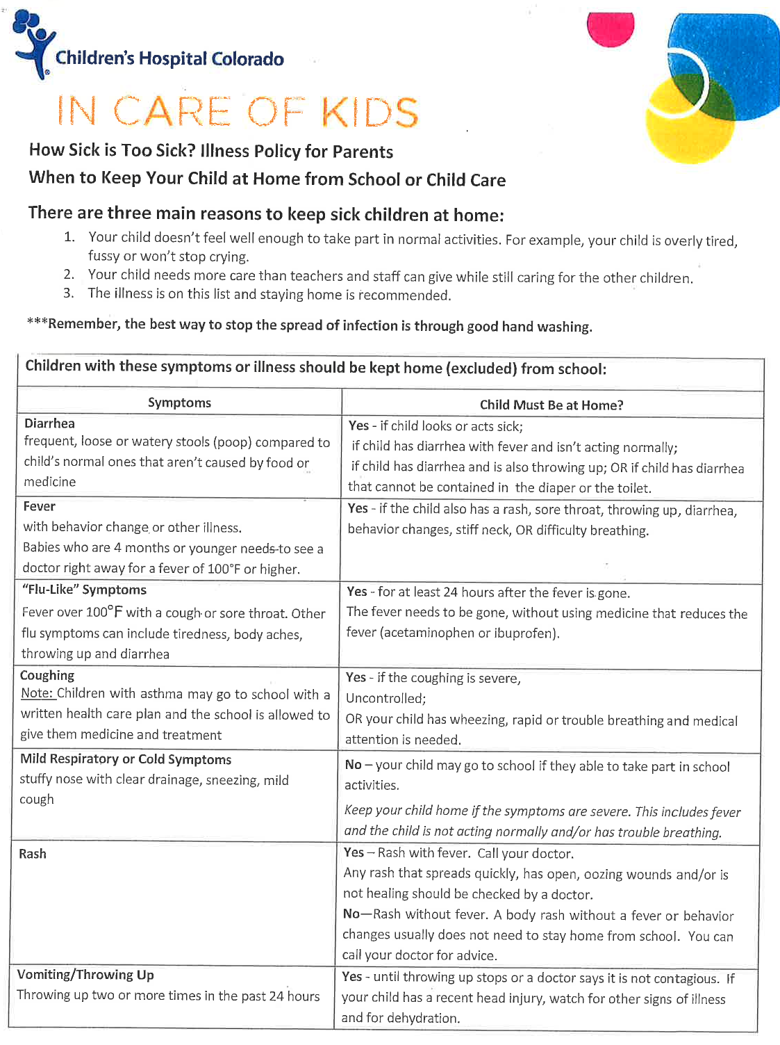

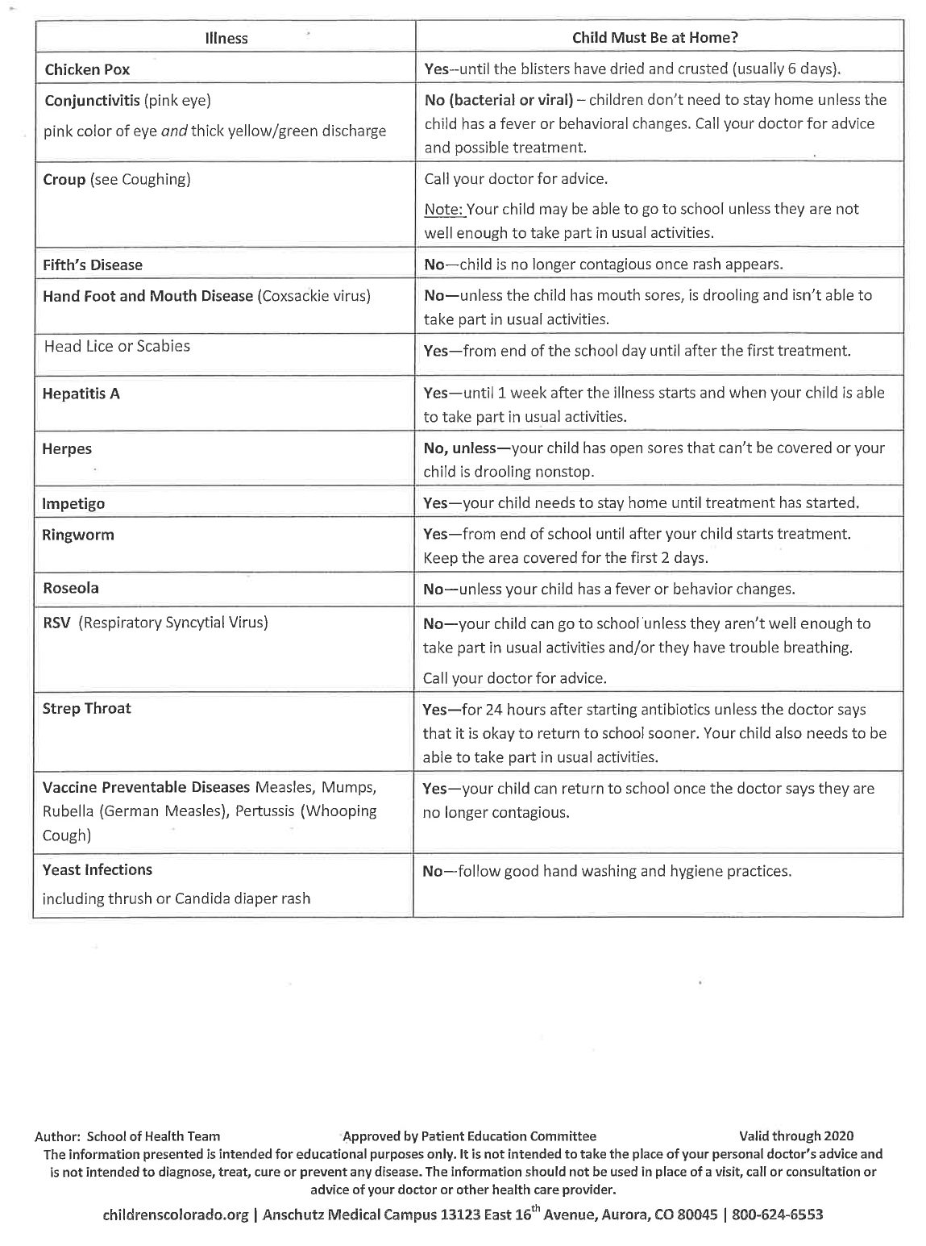

SCHOOL SAFETY
The safety and security of every student is of paramount concern at DPCA. As a school, we work hard to train our staff, faculty, and students with great regularity and consistency to plan, prepare, and practice for a variety of emergency situations. DPCA has an organized, systematic emergency operations plan in place to reduce risks, to prevent, prepare for, respond to, and recover from a wide variety of crisis situations as well as plan for daily security and safety. Read on for more ways we practice safety.

RESTRICTED ACESS

There are five total possible entry points to our school and four of these are only accessible to staff with a designated key, as these remain locked at all times. The fifth is the main entrance which requires access to be granted through a secondary set of doors via a buzzer system after the office manager has identified the person wishing to gain entry. All other exterior doors remain closed and locked at all times. Additionally, all interior classroom doors remain closed and locked when students are in class.

PICK-UP AUTHORIZATION

Parents who need to take their children from school during the school day for doctor’s appointments, sickness, family outings, or similar occasions are asked to complete the family sign-out log at the office. By doing this, we have confirmation that the student is with his or her parent(s)/guardian and we know what to expect regarding time and date of the student’s return, if returning that day.

Students will only be allowed to leave school with persons noted on their Pick-Up Authorization form (included in the Enrollment Package), with exceptions made for parents who call in to add an adult to this form.

SCHOOL VISITORS

Please contact the office and classroom teacher when wanting to visit. Visitors must sign in at the front office and receive a visitor pass before proceeding to other parts of the building.

Visitors are reminded that they are not to disrupt the learning environment and are not to enter the classrooms during the school day without permission from an administrator.

If a parent/visitor needs to meet with the teacher, contact the teacher to schedule a time.

Visitors such as prospective families or local experts contributing to academic expeditions must be approved in advance by the Head of School with notification given to teachers.

BACKGROUND CHECKS

Background checks are completed for all staff, parents and volunteers who either work directly with students on a regular basis or chaperone any extended school sponsored event that is overnight.

Restricted access to the building through a “buzzer” entry system requiring users to contact the office and verbally identify themselves for entry into the building during school hours. Doors will be locked after the start of each school day and reopened prior to dismissal.

In the event of an emergency, please call the school at (719) 395-6046. If after school hours, please email l.graff@dpcaweb.org and someone will get back to you shortly (messages are sent to personal cellphones and are reviewed regularly).

STUDENT PHOTO PERMISSIONS

Often, we take photos of students working on projects, during assemblies/chapel time, on fieldwork expeditions, etc. These photos are placed on our website and social media, most often without identifying information like first and last names. If you would like to opt out of this and request that photos of your child are not posted, please fill out the correct information in the enrollment packet. It can also be requested at the front office.

STUDENT RECORDS

Parents are welcome to contact the office to request their student’s records. Other education entities requiring student records can email us directly to ask for records (office@dpcaweb.org). If an unexpected source contacts us directly, we will confirm with the parents that those records can be released to that source.

SENSITIVE SCHOOL SPACES

DPCA adheres to a Biblical definition of gender (Genesis 1:27) with biological sex being determined at a chromosomal level upon birth. It is specifically not a choice made by parents or students. Student restrooms, locker rooms, showers, or any other part of the school facility, permanently or temporarily, designated for the use of one biological sex for any reason at the discretion of school administration shall be restricted to the use of members of that biological sex.

In addition, in order to protect students, staff members, and volunteers, adults and students are restricted from being in a secluded area. For example, if a student and teacher meet one on one then the classroom door is open and they will be seated in a visible area to the outside hallway.

SAFETY DRILLS

Safety drills are required by law and are important to practice in the event of a real emergency. Students learn the evacuation path established for each room they occupy. Conduct rules during these safety drills are enforced. All building occupants must move silently and in an orderly fashion to a specified area where they remain until instructed to return to the building. DPCA practices at least one fire drill a month in addition to lockout, and lockdown drills each semester.

Lockout: Occurs when the threat is away from the school; perimeter is secured by bringing students and staff inside and closing doors. School administration secures the building and safely shelters all students, staff, and visitors INSIDE the school building. Business is as usual inside the school. No person is allowed to enter or leave the building.

Lockdown: Occurs when the threat is inside or very near school. Lights are turned out and classroom doors are locked. People move away from sight, stay silent, and roll is taken. School business and activities cease and no person is allowed to enter or leave the building.

Evacuation: An evacuation occurs to prevent injury or harm due to a hazardous situation inside of the school, such as a fire. All students and staff will exit the school and go to designated locations:
Valley Fellowship Church Cornerstone Church
608 S. San Juan Avenue 205 S. San Juan Avenue
(shares a parking lot with the school) (for situations in need of further distance)

Reunification: This event will occur if students have been moved away from DPCA to an evacuation site. During this process, students can only be released to an adult listed as an emergency contact at the school. In addition, the person picking up a student must bring proper government issued photo identification (driver’s licenses, state ID, etc.)

IN THE EVENT OF A SCHOOL EMERGENCY

· DO check your email, the DPCA webpage, and social media links for updated information (www.dpcaweb.org). We will send out REMIND texts and updates so that you are aware of what is going on and know that your child is safe.

· DO NOT go to your child’s school. This will create traffic congestion hampering the efforts of first responders.

· DO NOT call your child or your child’s school. Excessive phone calls could jam the phone system and interfere with emergency communications.

INVESTIGATIONS

For the safety and well-being of all students enrolled at DPCA, staff may need to investigate suspected or alleged violations of school policy or public law. Such investigations may include (but are not limited to) the following actions on the part of the Head of School or his/her designee:
- Interviewing student(s) involved in a conflict, those making allegations, and those who are allegedly guilty of a violation.
- Searching of school property including: Lockers, desks, bookshelves, “cubbies”, storage cabinets, computers, and all other rooms, furnishings, and equipment located within the school. These are school property even if being used by or assigned to individual students and are subject to inspection or search at any time without prior notice to students or parents. No right to privacy regarding school property exists or is implied.
- Searching of personal property: if reasonable suspicion warrants, students may be asked to show the administrator the contents of personal property such as backpacks, notebooks, purses, electronic devices, or travel bags.
- If the suspicion involves substances or items that may injure the student or others, the search may include a request for a bodily search in the presence of the student’s parent(s).
- Parents or students unwilling to comply with the requests for searches or information will be assumed to be in conflict with school safety, and students may be suspended pending further resolution of the conflict.
- Suspected violations of public law, or evidence of a violation of law gathered as noted above, will be referred to the local police department.

TUITION, FEES AND PURCHASES
2020-2021 School Year
 | Tuition | Additional Fees*  Registration Fee per family
PreK 2.5-5 Yrs  2 Mornings per Week | $1,469 | $45 annual Registration Fee**
PreK 2.5-5 Yrs  2 Full Days per Week | $2,464 | $45 annual Registration Fee**
PreK 2.5-5 Yrs  4 Mornings per Week | $2,938 | $45 annual Registration Fee**
PreK 2.5-5 Yrs  4 Full Days per Week | $4,922 | $45 annual Registration Fee**
Kindergarten  Mornings Only | $3,310 | $85 annual Registration Fee**
Kindergarten  Afternoons Only | $2,938 | $85 annual Registration Fee**
Kindergarten  All Day  (Lunch Program Available for Additional Cost) | $5,146 | $85 annual Registration Fee**
Grades 1 – 5  (Lunch Program Available for Additional Cost) | $5,554 | $85 annual Registration Fee**
Grades 6 – 8  (Lunch Program Available for Additional Cost) | $6,202 | $85 annual Registration Fee**
Kindergarten – PER Core Class (Math/Science/LA/Social Studies)  Necessary? | $661/class | $45 annual Registration Fee**  Necessary?
Kindergarten – PER Elective Class (PE/Art/Music) | $246/class | $45 annual Registration Fee**
Kindergarten  - PER Outdoor Expedition (4 per year) | $45/exp
Grades 1-5 – PER Core Class (Math/Science/LA/Social Studies) | $1,110/class | $45 annual Registration Fee**
Grades 1-5 – PER Elective Class (PE/Art/Music) | $410/class | $45 annual Registration Fee**
Grades 1-5  - PER Outdoor Expedition (4 per year) | $60/exp
Grades 6-8 – PER Core Class (Math/Science/LA/Social Studies) | $1,229/class | $45 annual Registration Fee**
Grades 6-8 – PER Elective Class (Various Courses TBD) | $454/class | $45 annual Registration Fee**
Grades 6-8  - PER Outdoor Expedition (4 per year) | $85/exp

PAYMENT

School tuition payments can be made in a few ways:

- Lump Sum: Tuition is paid in full and will receive a 2% discount and is due by August 1st;
- Bi-Annual: Tuition is divided in two and is due by August 1st and December 1st;
- Monthly: Tuition is paid over 10 or 12 months (parents’ choice) and is due on the 1st of each month. Service fees and late fees apply.

WITHDRAWAL FROM SCHOOL

Voluntary withdrawal from DPCA is initiated by the parents by notifying the school administrator, in writing, of the student’s planned last day of school. Parents withdrawing their students from DPCA may be asked to complete a brief survey, and a personal meeting with the administrator would be greatly appreciated.

REFUND POLICY

Refunds will be given to those who have paid tuition in full for the year, and will be pro-rated to the end of the withdrawal month.

Refunds will be given to those who have paid tuition bi-annually, and will be pro-rated to the end of the withdrawal month.

No refunds will be given those who pay monthly.

LUNCH FEES

DPCA offers a healthy and fun lunch program for students in all-day Kindergarten through 8th Grade. Lunch menu calendars and order forms are sent home at the end of the month in Thursday Folders. Payment for lunches is due when you hand in your order forms. Lunches are $3 for K-5th Grade and $3.50 for 6th-8th Grade. Every Friday is Pizza Day! Pizza meals include a fruit or veggie, cookies, and milk and are $3 for one pizza slice, $3.50 for 2 slices, with additional slices for $1.00 each.

When students receive a lunch that has not been paid for (eg. forgot lunch, wrong day, etc.), an email will be sent to the parents requesting payment.

With the exception of unexpected fieldtrip days, unexpected school closures, and prolonged student illness, credits will not be issued for lunches not received. Food and supplies are purchased in advance and based on what has been ordered, as such, there is still a cost involved even if your child misses lunch that day. We appreciate your understanding in this regard.

ONLINE PAYMENT

Please keep in mind that we do offer online payments for tuition, lunch fees, DPCA hoodies, and DPCA beanies on our website ( www.dpcaweb.org ). Service fees apply. If paying for lunches, hoodies or beanies online, please be sure to send in the lunch order form to the office.

ADDITIONAL RESOURCES
Include our STATEMENT OF FAITH & more information about EXPEDITIONARY LEARNING

Expeditionary Learning schools promote a strong culture of best effort, high expectations,
teamwork, adventure and service and foster a climate of respect, inclusion, and respect for
diversity.
• THERE IS A CONSISTENCY BETWEEN WHAT IS EXPECTED OF STUDENTS AND WHAT
IS EXPECTED OF ADULTS. Staff strives to model a spirit of inquiry, reflection, critique,
revision, and collaboration in their professional practices and relationships and strives to ignite
and sustain these qualities in students.
• High quality learning expeditions are at the center of the curriculum. Learning expeditions are
long-term, in-depth investigations of a theme or topic that engage students through authentic
research, projects, fieldwork, service, and adventure.
• Each learning expedition is defined by a series of significant projects that serve as a primary
structure through which students learn skills and engage with content. Projects may focus on
work from a single discipline or they may connect work from multiple disciplines. Projects
involve students in original work and research and focus on critical thinking skills. While
projects define a common body of work and expectations for ALL students, the richness and
complexity of a well-designed project allows students across a wide range of abilities to be
pushed to a challenging level.
• FIELDWORK and the use of outside experts enrich and motivate the learning within projects.
They create a real-world context for learning, and strengthen the connection between school
and community. Families are actively recruited for involvement in these activities. STUDENTS
ARE REQUIRED TO PARTICIPATE IN FIELDWORK ACTIVITIES AND A SIGNIFICANT
PORTION OF THEIR GRADE IS BASED UPON THIS PARTICIPATION.
• A high level of engagement and achievement is supported by the consistent use of
instructional practices including creating explicit assessment criteria, providing models of
exemplary work from the school or professional world, expecting multiple drafts, and critiquing
work from peers and adults.
• HIGH QUALITY STUDENT WORK is a central focus of the school culture. Work is displayed,
showcased, and celebrated throughout the school. Portfolios and exhibitions serve to both
assess and motivate student learning. Assessment data at PPSEL will be based equally on
traditional test data as well as exhibitions, portfolios and fieldwork.
• Habits of character such as perseverance, compassion, craftsmanship, self-discipline and
commitment to service are viewed as inextricably linked to success in school and beyond and
are actively developed and celebrated by the school community.
• Expeditionary teaching and learning is supported by WHOLE SCHOOL structures including:
§ Schedules that provide long, flexible blocks of time for projects and fieldwork.
Teaming structures that create small learning communities, facilitate collaboration across
multiple disciplines, and create multi-year relationships between students and their teacher
or team of teachers.
§ Budgets that prioritize resources for instructional materials, fieldwork costs, and staff
development.
§ Homework counts for significant percentage of the course grade in each class. We believe
that excellence demands effort; both in the classroom and at home, and students reenforce what they are studying at school and develop a more disciplined mind by doing
homework.
All families who send their children to Pikes Peak School of Expeditionary Learning commit to
attending family conferences, exhibitions and celebrations of student work. By attending exhibitions
and conferences, families and teachers get acquainted and understand students’ academic and
social performance better. It also provides authentic recognition for real-world work on the part of the
students.
• Many of our students have unique learning needs that require extra support on the part of the
instructional staff. We expect parents of PPSEL to partner with the staff and students in giving
a helping hand to those students needing extra attention.
• Much of the research that is required of PPSEL students is done in small groups or
individually. It requires a growing ability on the part of our students to work responsibly and
productively when they are in their small groups or alone. Students who become habitually
disruptive to this process will be required to have their parent or guardian monitor them during
these times so that others can continue their work.
• Teacher planning time that is frequent and focused;
• Shared leadership and inclusive school governance.
Fieldwork
Students are strongly encouraged to participate in fieldwork activities since they are an integral part of
Expeditionary Learning and a significant portion of their academic assessment. Fieldwork is planned
at an age and grade appropriate level and may include overnight trips and some out-of-state trips in
upper grades. Since our school does not provide transportation, we rely heavily on parent volunteers.
Homework
PPSEL believes that homework is generally used for reinforcement of concepts, finishing work not completed in the classroom, and for working on larger projects. Students should expect around 10 minutes of homework multiplied by their grade level (for example, a 3rd grade student might have 30 minutes of homework a night— 10 minutes times 3). Homework should not include students learning new concepts at home.
Adventure
Adventure helps to create the student engagement and focus on character that distinguishes the EL
experienc22e. Adventure can be any physical, artistic, or intellectual experience that involves risk,
challenge, and discovery. Every adventure has a strong element of entering the unknown and not
being certain of the outcome. EL promotes the kind of adventures that create opportunities for
leadership and collaboration as groups of students and teachers face challenges together. Together,
students and adults discover they can do more than they thought was possible, and find aspects of
themselves that they didn’t know were there.
Service
Service learning is an integral part of academic work - it teaches students that the skills they are
learning can be put to use to make a better community. Service learning goes beyond charitable
volunteer work to include projects that address important academic skills (e.g., beyond collecting
clothing for the homeless, it may involve creating a guide to free city services that can be distributed
at homeless shelters).

